**CHAPTER 7: PROJECT TRACKING AND CONTROL PLAN**

**7.1 Gantt Tracking Chart(Monish Vadhwani):-**

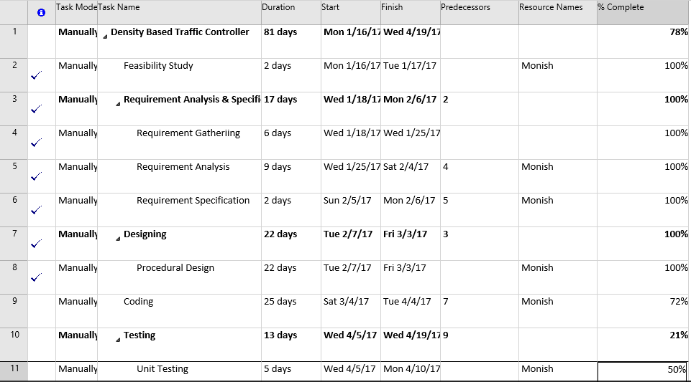

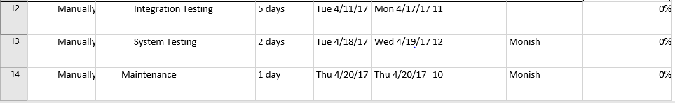

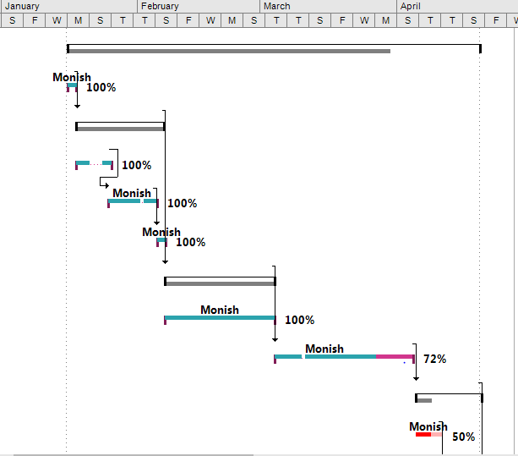

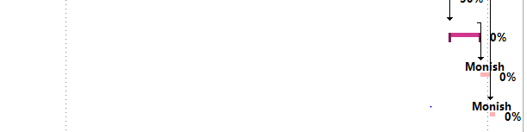

Fig 7.1 Tracking Gantt

**7.2 Gantt Tracking Chart(Umang Kanage):-**

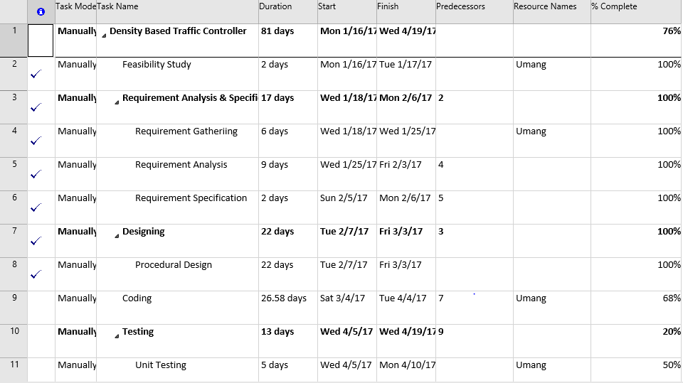

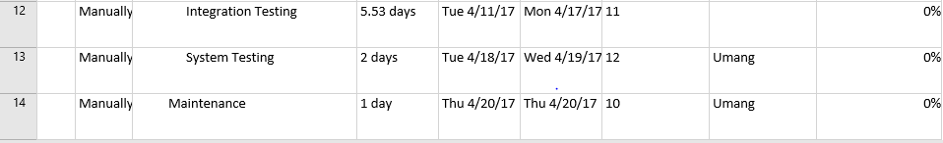

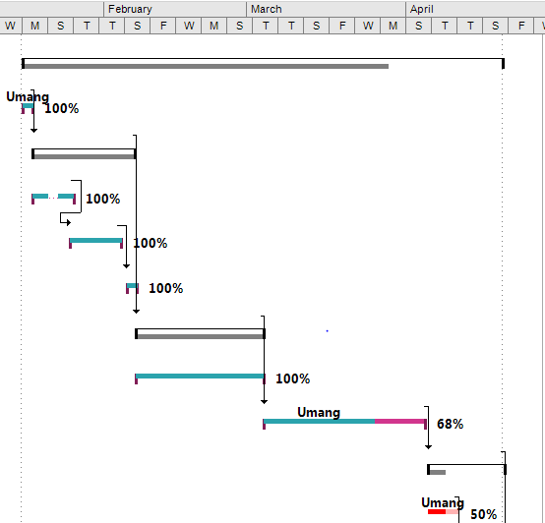

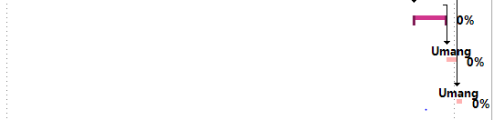

**7.3 Gantt Tracking Chart(Yash Sonar):-**

